# **Conditional Statements**

* Do now: Variables
  + Write down 3 const and 3 let variables. Explain the difference between const and let. Try to challenge yourself when making your variables. For example, use some mathematical operators.
    - Extra challenge options (*maybe don’t show examples, unless the students don’t remember):  
      1. use string concatenation or string interpolation to log some text and one of your variables to the console.  
        
       string concatenation:

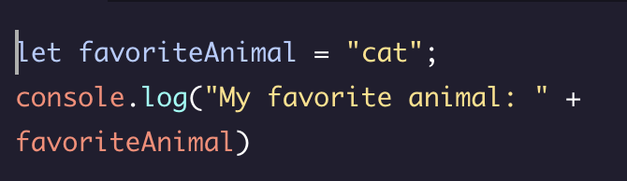

string interpolation:

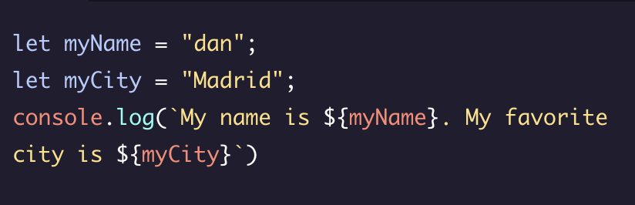

2. log to the console the type of your variable using typeof. Example:

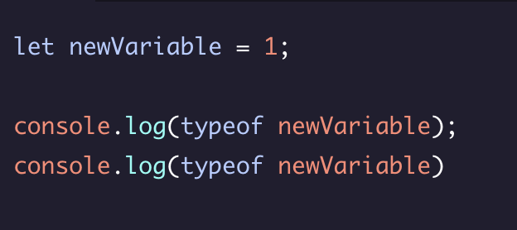

* + Review do now, ask for questions
* Main Lesson